CLIENT INTAKE FORM
PERSONAL INFORMATION
FULL NAME: _______________________________________________
GENDER: M or F
ADDRESS: _________________________________________________
CITY _______STATE_____ ZIP CODE______________
DATE OF BIRTH____________________________
CELL PHONE: ______________________________
EMAIL: __________________________________________
OCCUPATION: _______________________________________
EMPLOYER: __________________________________________
REFERRED BY_______________________________________
HOW DID YOU HEARD ABOUT US? _______________________________
Current HEALTH HISTORY (PLEASE CIRCLE/ CHECK MARK )
Reason for initial visit____________________________
Do you exercise regularly and/or participate in any sports? Y or N
If yes, what kind of exercise/sports?
Do you perform any repetitive movement in your work, sports or hobby? Y or N
If yes, describe________________________________
Do you sit or stand for long hours at a workstation, computer or driving or standing? Y or N
If yes, describe________________________________
Do you experience stress in your work, family, or other aspect of your life? Y or N
If yes, describe_________________________________________
Are you experiencing tension, stiffness, discomfort or pain? Y or N
If yes, describe ________________________________________
Have you recently had an injury, surgery, or areas of inflammation?
If yes, describe_________________________________________
Are you pregnant? _______ If so what trimester are you? _______
Do you have sensitive skin? Y or N
Do you have any allergies to oils, lotions or ointments? Y or N
If yes, please explain ___________________________________
List any medications you are currently taking?
____________________________________________________________________________________________________________________
Any allergies_______________________________________________
MASSAGE INFORMATION
Have you had a professional massage before? Y or N
What type of massage are you seeking?
___ Relaxation ____ Deep Tissue
What pressure do you prefer? __ Light __ Medium ___ Deep
Are there any areas (feet, face, abdomen, inner thigh etc) you do NOT want massaged? Y or N Please explain:

Please circle the area of discomfort:
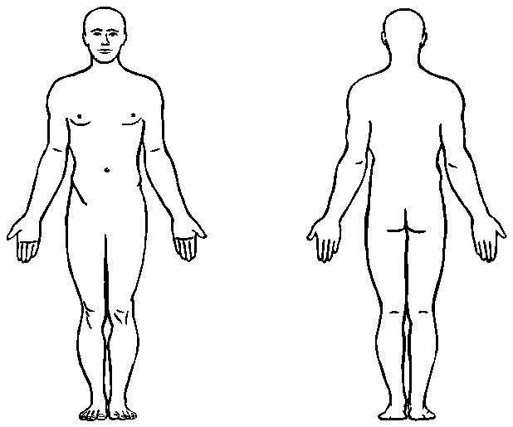
By signing below, you agree to the therapeutic massage and its service. I have completed this form to the best of my ability and knowledge and agree to inform my therapist if any of the above information changes at any time.
Client Signature ____________________________________Date __________
Therapist Signature _________________________________Date __________

